

Year 7 History Study Guide
British History: 1066-1688
• The Stuarts •
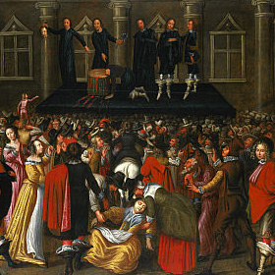

Contents

The Stuarts
Lesson 1 – Who are the Stuarts? | pg. 3
Lesson 2 – Freedom fighters or terrorists? | pg. 8
Lesson 3 – What is a civil war? | pg. 11
Lesson 4 – What helps decide what you believe in? | pg. 14
Lesson 5 – Why did Parliament win? | pg. 16
Lesson 6 – Can you be loved and hated at the same time? | pg. 17
Lesson 7 – Is having power a good thing? | pg. 18
Lesson 7 – Is having power a good thing? | pg. 22
Lesson 8 – Charles II: King of Bling? | pg. 24
Lesson 9 – Can good things come out of bad situations? | pg. 26
Assessed Task 3 | pg. 28

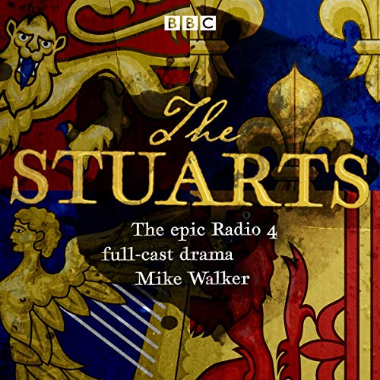

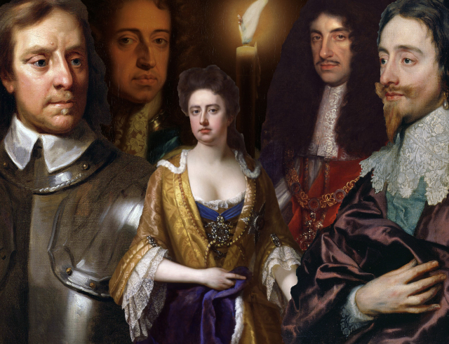

Lesson 1 – Who are the Stuarts?
Task 1 – Stuarts Facebook profile
Over the next couple of pages, you will find key information on three Stuart kings and Oliver Cromwell. You are to choose one of these individuals and then create a Facebook profile of the individual.
When creating your profile, remember to think about their profile picture, status updates, interests, likes/dislikes, friends, photos, messages on their wall and anything else you can think of.
Facebook profile

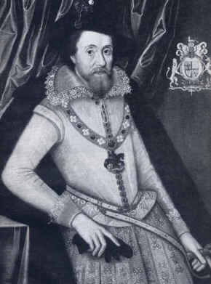
James I
James I succeeded the last Tudor monarch, Elizabeth I, in 1603. James at the time of Elizabeth’s death was king of Scotland. He was also the nearest blood relative to Elizabeth.
James was a Stuart – the first Stuart King of England.

His education was very religious and he was pushed very hard by his teachers George Buchanan and Peter Young. However, James became fluent in Latin and French and competent in Italian. In his early years, James developed a great desire for knowledge but got very cocky. He believed that he was capable of out-arguing almost anyone. This made people dislike him.

James became king of England aged 37. At the English court, his appearance was a source of comment, though not criticism. He was tall and broad shouldered.
He was also quite rude to people. In a session with Presbyterian ministers, James shouted at them, “I give not a turd for your preaching.” James was a strong believer in the Divine Right of Kings. He believed he had been chosen by God to rule so no-one could argue with him. He got rid of people he did not like, and stuck to arguments he knew were wrong just to make a point. This meant he made bad decisions and people disliked him.

James was a Protestant, and some people thought he was being too soft on Catholics. The 1605 Gunpowder Plot seemingly solved the Catholic issue. Some Catholics who hated James planned to blow up the House of Parliament while he was in it, but they were caught. James had them hung drawn and quartered to show other Catholics never to rebel. Because it hadn’t been blown up, Parliament was nicer to James. They gave him lots of extra money to spend. But James became more and more extravagant, spending all the money on himself. James also believed that his three children – two boys and a girl – should also live in a manner befitting princes and a princess. He wasted most of the country’s money.

James failed to understand that the people of England wanted to see their king. On one occasion when told by a courtier that the public wanted to see him, James replied “God’s wounds! I will pull down my breeches and they shall see my bum!”

From the earliest years of his reign, James made mistakes. He put his best friends in charge of the country, despite the fact they did not know how to run it. He was also very lazy and expected others to do his work. He lost control of Parliament and never got it back. James died on March 27th, 1625, at his favourite hunting lodge – Theobalds in Essex. His funeral was described as magnificent, confused and disorderly.
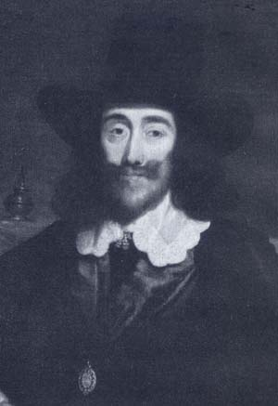
Charles I
Charles I was born in 1600 in Fife, Scotland.
Charles was the 2nd son of James I. His elder brother Henry died in 1612.
Charles I became king of England in 1625. He was the second of the Stuart kings.
Charles was a quiet person who tended to stay in the background as he had a stammer.
Charles may have been just over 5 feet tall and people made fun of him for being so small. In the paintings of Charles and his family, his children are either sitting while he stands or they are on the floor at his feet.
Charles spoke many languages and he developed a great love of art. Van Dyck and Rubens painted in England at his invitation and Charles spent a fortune on paintings. His collection of art, though impressive, also helped to put him in a very difficult financial position – he spent too much of the country’s money.
Charles was a very religious man and he preferred church services to be grand and full of ritual and colour. This was to lead to a clash with many in England who preferred plain and simple services.
Charles also angered many by having favourites at court. His most favoured advisor was the Duke of Buckingham who was murdered in 1628. Parliament agreed that Charles could pick his own advisors but only if the person appointed was acceptable to them.
Constant arguments with Parliament over many issues led Charles to lock out Members of Parliament for 11 years - from 1629 to 1640 (the so-called Eleven Years Tyranny). He also believed in the Divine Right of Kings so he thought he could do what he liked!
Charles raised taxes and forced people to pay lots of money to him. He did this because he’d already spent so much. Everyone in England was very, very angry!
In 1637, Charles tried to impose a new prayer book on the Scots - he had been crowned King of Scotland in 1633. The Scots wanted simple and plain prayer services while the new prayer book required more ritual and grandeur. This clash led to the Scots invading England and occupying Durham and Newcastle.
In November 1640, Charles was forced into recalling Parliament as only they had the money needed to finance a war with the Scots. Parliament was only willing to assist the king if he agreed to their demands, but Charles refused.
Both king and Parliament were on a collision course. In 1642, Charles attempted to arrest his 5 leading critics in Parliament. They fled. Charles then ran away to Oxford and gathered an army. He declared war against Parliament, which became known as the English Civil War. It lasted 7 years, until Parliament won.
Charles was arrested and executed in 1649 – the only English king this had ever happened too changing History forever.

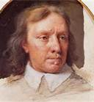
Oliver Cromwell

Oliver Cromwell remains one of our most famous characters in history.
From 1649 to 1653, Parliament ran England but from Cromwell's point of view, it was not a system that worked effectively and Cromwell, backed by the army, sent home MP’s and he became the leader of England from 1653 to 1658.
He was the man who really pushed for the execution of Charles I as he believed that Charles would never change his ways and that he would continue to be a source of trouble until he died.
Cromwell was a Puritan. He was a highly religious man who believed that everybody should lead their lives according to what was written in the Bible.
One of the main beliefs of the Puritans was that if you worked hard, you would get to Heaven. Pointless enjoyment was frowned upon. Cromwell shut many inns and the theatres were all closed down. Most sports were banned. Boys caught playing football on a Sunday could be whipped as a punishment.
Sunday became a very special day under Cromwell. Most forms of work were banned. Women caught doing unnecessary work on the Holy Day could be put in the stocks.
He divided up England into 11 areas; each one was governed by a major-general who was trusted by Cromwell. Most of these generals had been in Cromwell’s New Model Army.
Cromwell believed that women and girls should dress in a proper manner. Make-up was banned. Too colourful dresses were banned. Cromwell banned Christmas as people would have known it then. In London, soldiers were ordered to go around the streets and take, by force if necessary, food being cooked for a Christmas celebration.
Despite all these rules, Cromwell himself was not strict. He enjoyed music, hunting and playing bowls.
Cromwell had a hatred for the Irish Catholics. During his time as head of government, he made it his task to ‘tame’ the Irish. He used terror to ‘tame’ the Irish.
By the end of his life, both Cromwell and the 11 major-generals who helped to run the country, had become hated people. The population was tired of having strict rules forced onto them. Cromwell died in September 1658.
His son, Richard, took over leadership of the country. However, Richard was clearly not up to the task and in 1660 he left the job. Charles II was asked to return to become king of England. One of Charles’ first orders was that Cromwell’s body should be dug up and put on 'trial' as a traitor for regicide (someone who is responsible for the execution/murder of a king or queen). His body was put on trial, found guilty and symbolically hanged from a gallows at Tyburn (near Hyde Park, London). What was left of his body remains a mystery. His head was put on display in London for many years to come.

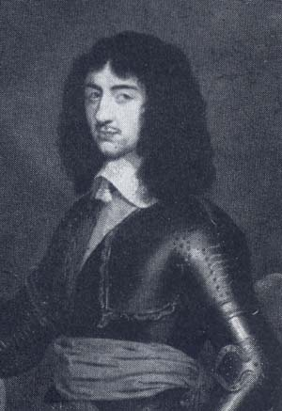
Charles II
Charles II, son of Charles I, became King of England, Ireland, Wales and Scotland in 1660 as a result of the Restoration Settlement. He was the third Stuart King. Charles was born on May 29th 1630 at St. James’s Palace in London. He received his education from the Bishop of Chichester and the Earl of Newcastle. However, what would be deemed his formal education ended when the Civil War broke out in 1642. In 1645, Charles, the heir to the Crown, had to flee England. He spent the next five years as a royal refugee in Jersey, France and the Netherlands.

Charles heard that his father had been executed in January 1649. Charles then tried to attack Oliver Cromwell in 1650 but lost and ran away again. Charles lived with his mother in Paris.

However, in England people hated Cromwell and his harsh policies. Many celebrated his death and between 1658 and 1660, it became clear to the government that they needed to bring the King back.

Parliament wanted to make it clear that they would not accept any similar behaviour associated with Charles I, so Charles II would always be kept under control by Parliament. Charles II would not have needed reminding that his father had paid with his life as a result of taking on Parliament. Charles landed at Dover, Kent, on May 25th, 1660 and became King again. This was known as the Restoration. This was very popular and everyone celebrated.

Charles had a love/hate relationship with Parliament, but in the end Parliament got the upper hand and refused to give him more money! Charles went to war several times with the Netherlands – with mixed results.

Charles got very lazy and left Parliament to makes the decisions while he went off and enjoyed himself. He earned the nickname ‘the merry monarch’ because he was so playful. He was a real party boy and had big parties all of the time. He used to race his boat up and down the Thames - he always won the race because he had no-one to race against!

Charles had many mistresses while King of Great Britain. Charles acknowledged that he fathered fourteen illegitimate children (actually this was nearer twenty!). He treated his ministers the same way he did his mistresses; he used them but he didn’t trust anyone.

Charles II died from a stroke on February 6th, 1685. He died without a legitimate son/daughter.

Lesson 2 – Freedom fighters or terrorists? (The Gunpowder Plot)
Task 1 – What do you know?
In the box below, write down as much information as you know about the Gunpowder Plot which we now commemorate on the 5th November.
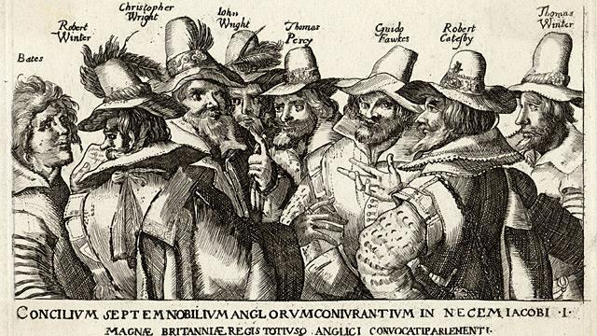

Task 2 – Gunpowder Plot storyboard
Using the information about the Gunpowder Plot, create a storyboard which helps animate what happened
A group of Catholics wanted to destroy the Protestant government in Parliament and place a royal catholic on the throne or rule themselves. Idea was to blow up the House of Lords at the opening of Parliament in 1605 – this would kill the King (a protestant) and Queen, some of their children/family, judges and MPs. The leader of the plot was Robert Catesby.

They firstly dug a tunnel under the HOL in Dec 1604 – but if filled with water.

In May 1605 Thomas Percy (had a position and court and cousin of Duke of Northumberland), rented a ground store-room room – under the Painted Chamber (which is next to the HOL and suddenly became available).

The plotters managed to smuggle 36 barrels of gunpowder into this storeroom (by river), they’d probably bought from merchants illegally. They then waited until Oct – in the meantime they tried to get more support from fellow Catholics. Parliament opening was then postponed until 5th November.

One of the Lords, Lord Monteagle, received a letter at the end on Oct. hand-delivered. It told him not to go to Parliament for the opening as he might be killed.

Monteagle passed the letter to the Earl of Salisbury, who showed it to the King. He ordered a search of parliament – a man was found with matches and torchwood – claiming to be John Johnson but under torture confessed to being Guido Fawkes by 7th Nov. Another day of torture and he gave the names of his fellow plotters.

60 people connected to the plot hid at Holbeach House, Staffordshire. They were captured or killed. Some were taken to be tortured, sentenced with High Treason and were then hung, disembowelled and chopped into quarters! They had been dragged through the streets first – to show how ‘bad’ the Catholics were. The King then passed laws to restrict Catholics.

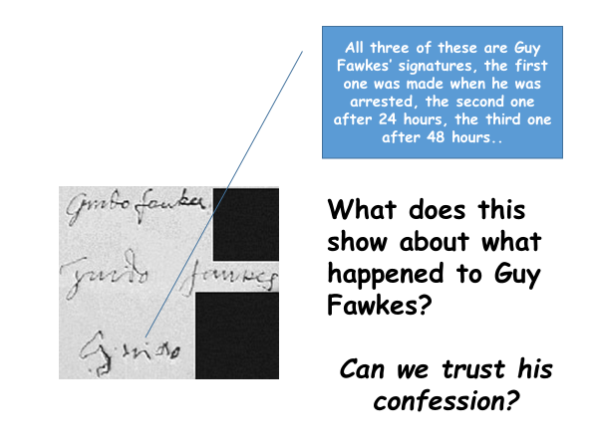

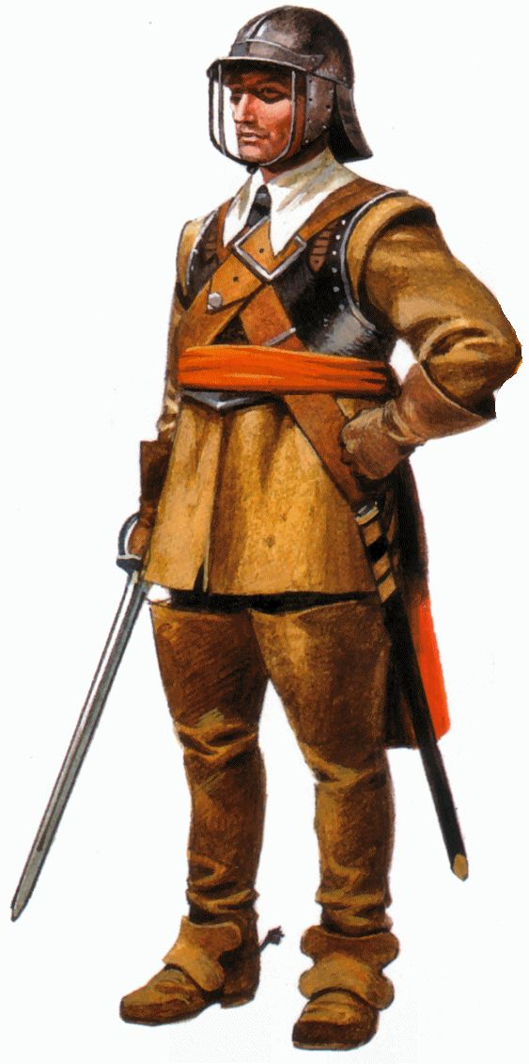
Lesson 3 – What is a civil war?
A civil war is when two groups within a country fight against one another.
Can you think of any famous civil wars that you might have heard of?

Task 1 – Why did Charles become unpopular
Using the statements, try and categorise the four key reasons why Charles became unpopular with the people, parliament and Scotland. The four main categories are:
ship taxes
power
money
religion.

1. In response to the ‘Petition of Right’, Charles knew that he could collect a tax called ‘Ship Money’ without having to ask Parliament. This was a tax that was collected from coastal towns at wartime to help build ships. Charles collected this every year, even though there was no war! |  | 2. “Everyone was told to pay the tax. However, we were at peace and our fleet of ships was already strong. If the King can create or collect whatever tax he would like and we are imprisoned when we refuse to pay, we are ruined” – a quote from a Puritan at the time. |  | 3. Charles wanted everyone to worship God in the same way. He ordered the people in Scotland to use the same prayer book as the English. |  | 4. Due to his spending, Charles had to ask Parliament for taxes. When Parliament questioned why he was spending so much money, Charles became angry.
5.  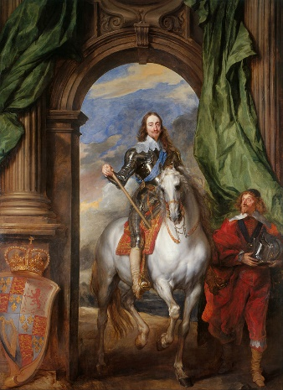 |  | 6. Charles was a big spender. As well as spending money on his family, favourites, friends and war, Charles spent a fortune on paintings. This spending put him in a difficult financial situation. |  | 7. Charles believed he could rule England without Parliament and he didn’t have the time to take notice of their worries and complaints. |  | 8. In 1628, Parliament created the ‘Petition of Right’ – this meant that no taxes should be collected without Parliament’s permission.
9. England was a Protestant country after many years of religious upheaval. Many believed that Charles was a secret Catholic. |  | 10.  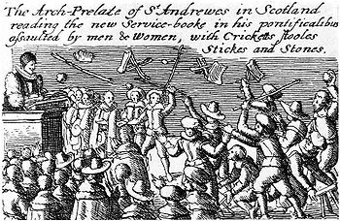  Scottish rioting for having to use the English prayer book. |  | 11. Hampden was brought to court and ordered to pay. Although disappointed, Hampden was encouraged that half of the judges on his case agreed with him and so did a lot of MPs. |  | 12. Charles’s wife was a Catholic and many believed that he was trying to get the Archbishop to make England Catholic again. Many people were unhappy with this.
13. John Hampden, a rich gentleman, believed that Ship Money was illegal and he refused to pay it.  “What an English King has no right to demand, an English subject has a right to refuse” |  | 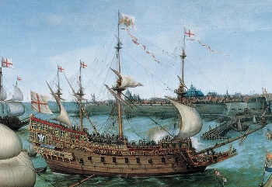  14. Sovereign of the Seas, a ship built during Charles’s reign using Ship Money. |  | 15. The Scots were outraged that they had to copy the English prayer book. The Scots formed an army and marched to England to fight Charles. However, Charles had no money for a war. Who should he ask for money? Parliament! |  | 16. Charles believed that he had been chosen by God to rule the English, and that his authority should not be challenged in any way. This was called the divine right of kings. This caused clashes with Parliament.

Task 2 – Most important?
Ship taxes, power, money and religion, which one do you think was the most important reason why Charles was disliked so much? Why?
____________________________________________________________________________________________________________________________________________________________________________________________________________________________________________________________________________________
How did the English Civil War start?
Having upset the Scottish by ordering them to use the same prayer book at the English, the Scottish formed an army and marched to England. With little money and strength to defeat the oncoming Scottish forces, Charles was forced to call Parliament to ask for money to raise an army.

Charles knew that calling Parliament would cause him great difficulties. He had ruled without parliament for eleven years and it was clear that the MPs were going to complain about his behaviour. Charles’ predictions were correct, and parliament refused to help Charles until he agreed to let them have more of a say in how the country was ran. Charles was so angry at Parliament’s requests that he sent them away and closed parliament.

However, Charles still had to deal with the invading Scots. Unable to get money to raise an army, Charles negotiated a humiliating peace treaty with the Scots, which gave into their demands and he even offered to pay their costs. Of course, Charles didn’t have the money to do so, so guess where he had to go again to ask for money? Parliament.

In November 1640, the Long Parliament met. Again, the MPs were furious at the way Charles had been running the country. Led by John Pym, they said that they wanted to settle their differences before any money would be given to the king. All seemed to be agreed until a rebellion started in Ireland. Wanting to raise an army to put down the rebellion, Charles asked for more money. Pym, scared that Charles would use the money and army against his own opponents in England, said that Parliament should control the army being sent to Ireland. Charles had had enough – he wanted to get rid of Pym.

In January 1642, Charles went to Parliament in search of Pym and four other MPs – he wanted them arrested! Charles burst into Parliament, realised that Pym and the MPs had been told he was coming and had ran away. Charles looked silly and he was furious.

Charles realised the only way he could maintain his authority was by defeating Parliament and its supporters in battle. On 22nd August he appealed for his supporters to join him. Parliament did the same and asked their supporters to join them. The Civil War had begun.

Lesson 4 – What helps decide what you believe in?
During the civil war, there were two side – those who supported the King (Royalists/Cavaliers) and those that supported Parliament (Parliamentarians/Roundheads).

For each of the people below, decide whether they would support the King or Parliament
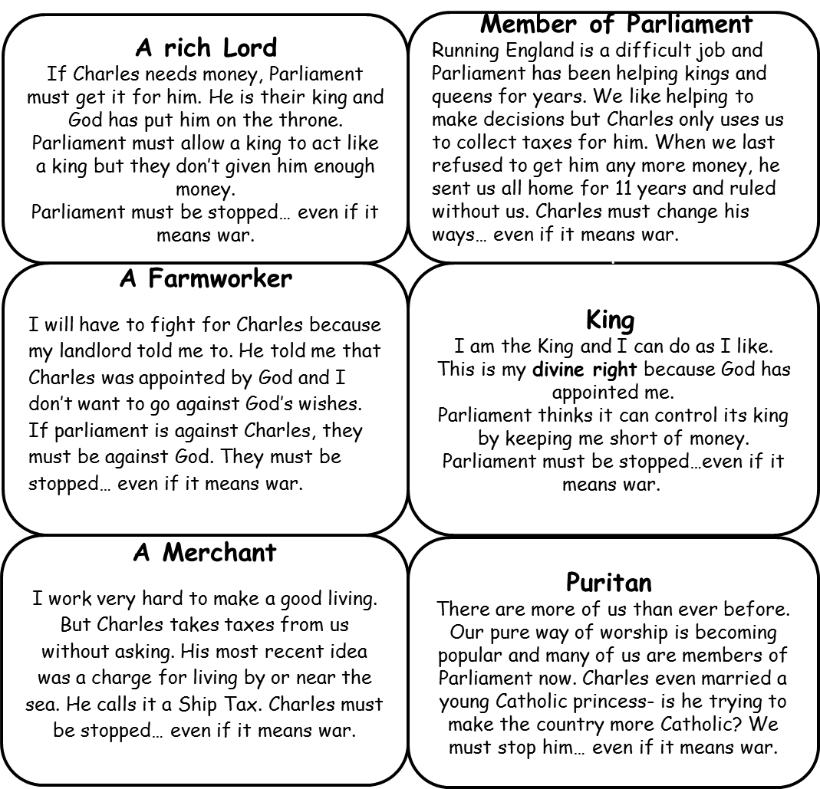

Why do you think religion played an important role in helping people to decide which side to support?
_________________________________________________________________________________________________________________________________________________________________________________________________________________________________________________________________________________________________________________________________________________________

A Royalist (Cavalier) might:  • believe in the Divine Right of Kings;  • agree that Charles had the right to take taxes such as ship money and grant monopolies when he wanted;  • support the bishops, and agree with Archbishop Laud's reforms in the Church of England;  • think people ought to obey the king, and that it was wrong to go to war against him.  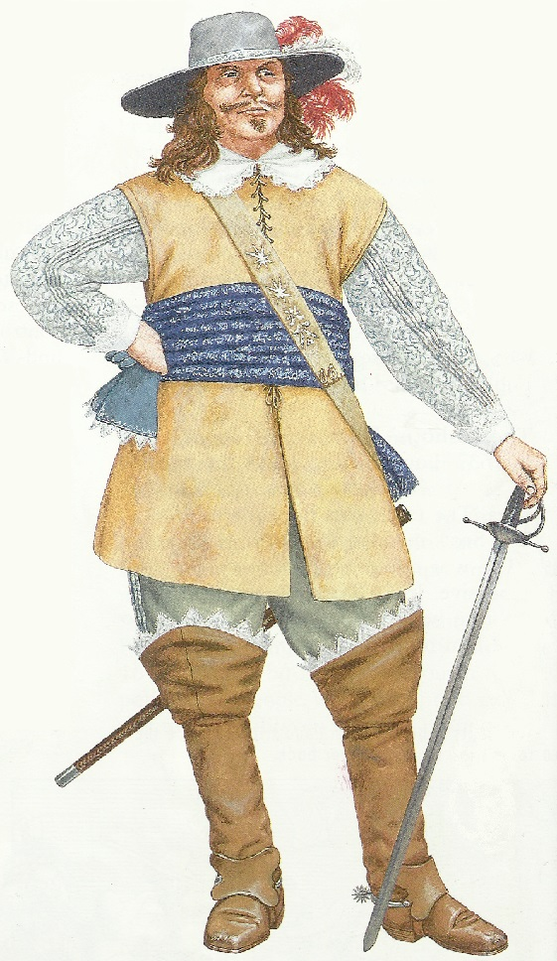 | A Parliamentarian (Roundhead) might:  • believe that Parliament should make the laws and govern the nation;  • believe in the principle of no taxation without Parliament's agreement;  • hate the bishops and want Puritan reforms to make the Church of England more Protestant;  • have no personal loyalty to the king, and believe that there was no need to obey the king if he was wrong.  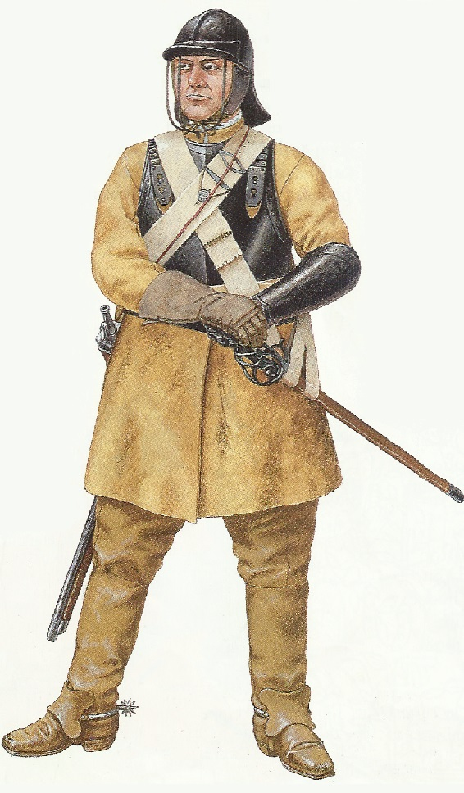

Which of the two soldiers looks better equipped to fight? Why?
_______________________________________________________________________________________________________________________________________________________________________________________________________________
Lesson 5 – Why did Parliament win?
Below is a description of key reasons why Parliament won the English Civil War. In the column on the right hand side of your page, complete a doodle map and turn the words into pictures, symbols and images (dates, initials and names are allowed too)
Information  Historians give a variety of different reasons for the failure of Charles.  These include the fact he did not take advantage of the strength of his position in the early part of the war.  Another factor was the fact his Army did not get on unlike the Parliamentarians.  The Royalist armies also suffered from poor leadership; in the early part of the war Charles appointed generals who were influential local men – this was good for getting support and bad when it came to the battlefield.  Prince Rupert, who was very inexperienced, the role of a commander. He did not know how to make tactical decisions, and this proved to be fatal at the Battle of Marston Moor in 1644. He thought that the Parliamentarians weren't ready, so everyone sat down to eat dinner, then they attacked!  No-one was ready so, despite fighting bravely, the Royalists lost and the Parliamentarians gained control of the north of England.  Another weakness was that the King ran out of money. He did have some rich supporters but their funds quickly dried up and lost men, in the areas that he controlled, refused to give him anything. As a result of this, at the battle of Naseby (which Parliament won) the King's soldiers were very badly equipped.  Also, many soldiers left his army as he couldn't afford to pay them.  Finally, controlling many ports (including London) and the fact that they had a total control of the Royal Navy meant that Parliament was able to supply its forces and strongholds very effectively, in comparison with the King. In addition, it also prevented Charles or his men receiving help from abroad or from Ireland. | Doodlemap
Lesson 6 – Can you be loved and hated at the same time?
After the king captured and the Royalists were defeated, Oliver Cromwell and the Parliamentarians were unsure of what to do – do they try the king for treason, and if found guilty should he be sentenced to death?
Task 1 – Guilty or not guilty
Below is a table with information relating to whether Charles was guilty of treason or causing harm to the people of England. You have to decide whether each statement supports that Charles was guilty or whether he was not guilty:
The King is a man of blood. He started both wars. | The people do not want to kill their King. | Some of Parliament want to put the King back in power. England needs a King. | England cannot survive without a King.
There is no Court that can try a King. | He was chosen by God to be King and cannot be Killed. | The King was to blame for the war and should die. | The victories of Cromwell’s armies show that God was on his side.
He fought against Parliament and his own people. | As long as Charles is alive there is a chance of another war. | The King cannot be trusted after the Second Civil War. | Most people are against Killing him.
Charles has wasted so much money not just on war but expensive art.

Read the four statements below. Which do you agree with most and why:
Charles made England
Charles was a terrible man
Charles wanted money and power more than he wanted to look after England
Charles did the best he could in the circumstances

Lesson 7 – Is having power a good thing?
Look at the picture below which shows you the execution of Charles I:
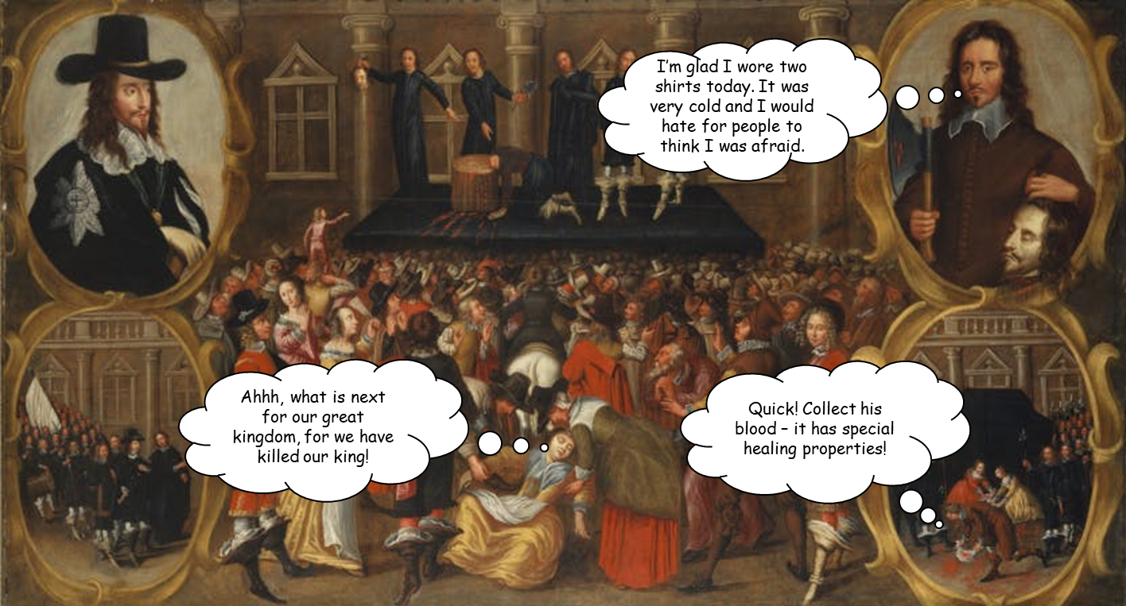

Task 1 - What do you notice and what does it tell you?
____________________________________________________________________________________________________________________________________________________________________________________________________________________________________________________________________________________
After Charles I was executed, the people of England were unsure of how the country should be ruled and governed. Oliver Cromwell was asked to be Lord Protector and preside over ruling the country.
Task 2 - Using the information on the next page, write a short biography of Oliver Cromwell’s life below:
1599 - Oliver Cromwell was born in Huntingdon, Cambridge.
1616 - Cromwell joined Sidney Sussex College, Cambridge University.
1617 - Cromwell’s father died. Cromwell left Cambridge University and returned to Huntingdon.
1620 - Cromwell married Elizabeth Bourchier.
1628 - Cromwell was elected Member of Parliament for Huntingdon.
1629 - Cromwell attacked bishops in a parliamentary speech.
1640 - Cromwell elected MP for Cambridge.
1642 - The English Civil War started. Cromwell raised a troop of cavalry in Huntingdon for Parliament.
1643 - Cromwell is appointed a colonel in the cavalry.
1644 - Cromwell is appointed a lieutenant-general in the Eastern Association. Cromwell fought at the Battle of Marston Moor in July.
1645 - The New Model Army created. It was led by Sir Thomas Fairfax and Cromwell was appointed a lieutenant-general in it. The New Model Army fought the Royalists at the Battle of Naseby in June
1647 - In June, after failing to reconcile the king, Charles I, Parliament and the army, Cromwell puts his full support behind the army.
1648 - Cromwell’s army defeated the Royalists at the Battle of Preston in August. In December, Cromwell pushed for a full trial of Charles I who was to be charged with treason
1649 - January 30th, Charles was executed. Cromwell’s signature was third on the death warrant. The Council of State of the Commonwealth replaced the monarchy.
1650 - In June, Cromwell was appointed Captain-General of the Commonwealth
1653 - Cromwell dissolved the Rump Parliament. In December, Cromwell was appointed Lord Protector of the Commonwealth
1654 - Cromwell sent a naval force to the West Indies which seized Jamaica
1655 - In May, the process started of dividing England into groups of counties under the command of a major-general. Their task was to enforce local government
1657 - System of major-generals ended. Cromwell was offered the crown of England but refused it.
1658 - September 3rd, Cromwell died. A state funeral was held in November.

Task 3 – Protector or dictator?
Below are a list of statements that relate to whether Cromwell was a protector, doing his best to look after England while there was no king, or whether he was a dictator, abusing his power to act almost like a king.
Using the statements below, put them in the table on the next page under the heading you think they best fit
A fair man who allowed Jews to practice their faith.
A forceful man who made people of England follow laws that would make them godly.
A forceful man who made the people of England follow laws that they did not like.
A great organiser; set up and led the Model Army.
A leader of men.
A man of conviction who waged war not only against Catholic Ireland but Protestant Scotland to ensure that no supporters of the King were left.
A man of principle. A defender of the rights of parliament.
A man who controlled his enemies with the army.
A man who stamped out bribery and corruption.
A man who took the most important title in England – Lord Protector – and who entrusted it to his son.
A plain man who believed in celebrations, plays and dancing should be outlawed.
A proud man who promoted England’s reputation in Europe, defeating Spain.
He banned Catholic worship in England.
He forced Irish landowners to move to Connaught in Western Ireland.
He forced towns to either surrender or die.
He invaded and killed many people in Ireland. In the siege of Drogheda, it is estimated that 3,000 Irish people were killed.
He invaded Ireland to protect England.
He led a good army and protected Britain.
He led the New Model Army.
He made people do everything in a Puritan way.
He made some wise decisions for Charles I.
He tried different government systems to rule England.
He was offered the crown – King Oliver? But refused it.
Popular and called ‘Lord Protector’
Protected England against the “Traitor” (Charles I)
Puritanism was about getting people into heaven, so he wanted everyone to go to heaven.
Protector | Dictator

Do you think Cromwell was a protector or a dictator? Why?
____________________________________________________________________________________________________________________________________________________________________________________________________________________________________________________________________________________
Lesson 8 – Charles II: The King of Bling?
Information – Bringing back the King
After Oliver Cromwell died, his son Richard, became Lord Protector. However, not many people liked Richard and he was removed from his position. Some from Parliament began to warm to the idea of bringing back the monarchy. Charles I’s son decided that he wanted to come back to England (he had been staying in France and the Netherlands for fear of being arrested). However, Charles had some persuading to do as many people in Parliament, and England, thought that he would be the same as his father. To settle people’s fears and concerns, he issued a series of promises called the Declaration of Breda.

In this declaration, or promise, he said that he would make sure there was peace in England, that he would listen to parliament, that he would not arrest those who fought against his father and that religious beliefs would be respected.

On the 29th May 1660, Charles rode into London and was crowned King of England.
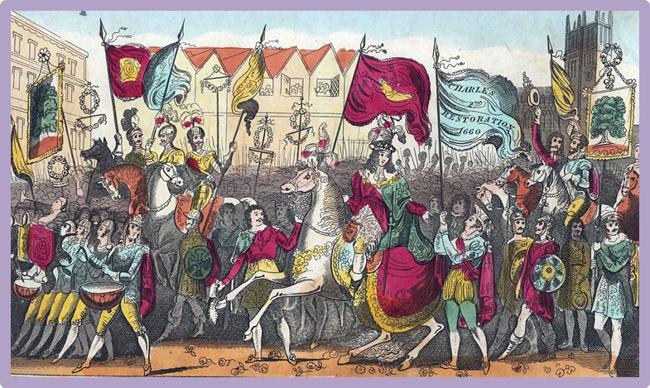
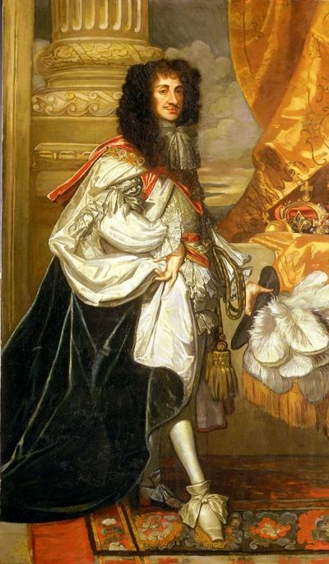

Task 1 – What did you learn about Charles II?
Watch the video link below and try and write down 7 facts that you learn about Charles II.
Horrible Histories – King of Bling - https://www.youtube.com/watch?v=FA5abHKvUBQ
- ______________________________________________
- ______________________________________________
- ______________________________________________
- ______________________________________________
- ______________________________________________
- ______________________________________________
- ______________________________________________
Task 2 – King of Bling
Below are the lyrics to the King of Bling song from the Horrible Histories video. Your task is to read through the lyrics to try and support or challenge what the song says about Charles II. Annotate around the lyrics down each side.
Charles II – The King of Bling
He is the second person called Charles who became King – his father was Charles I who was executed.

My name is, my name is, my name is – Charles the second
I love people and the people love me
So much that they restored the English monarchy
I’m part Scottish-French-Italian, a little bit Dane
But one hundred per cent party animal!
Champagne?
Spaniels I adored, named after me too
Like me they were fun with a natty hair-do.
Is today my birthday? I can’t recall
Let’s have a party anyway, because I love a masked ball

All hail, the King, of Bling, let’s sing, bells ring, dingding
I’m the King! Who brought back partying!

King Charles my daddy lost his throne and kings were banned
They chopped off his head, then Olly Cromwell ruled the land
Old Olly wasn’t jolly, he was glum and he was proud
Would be miserable as sin only ‘sinning’s not allowed’
When Cromwell died the people said ‘Charlie me hearty
‘Get rid of his dull laws, come back, we’d rather party.’
This action’s what they called the Monarchy Restoration
Which naturally was followed by a huge celebration

The King, of Eng-, land say, no sin, to sing, or anything.
All say I’m the King who brought back partying

Great London Fire was a whopper
In my reign London city came a cropper
So this King did what was right and proper
Fought the fire, proved I’m more than a bopper
I’m a fire-stopper!

Married Catherine Braganza, she was a love so true
There would never be another, well maybe one or two
Lucy Walter, Nell Gwynn, Moll Davis, Barbara Villiers
You think that’s bad but her name’s not as silly as ...
Hortense Manzini

As king I must admit I broke the wedding rules
But who cares when I brought back the crown jewels?
I reinstated Christmas, make-up, sport and even plays
I was the Merry Monarch they were Good Old Days

When said, and done, King Charles, did run, England, for fun
I was the King! Loved by everyone. My song is done.

Party anyone?
Lesson 9 – Can good things come from bad situations?
Information – The Great Plague
A summary
The plague appears to have started in the parish of St-Giles-in-the-Fields outside of London's walls in 1664. The hot summer seems to have caused it to become an epidemic. While 68,596 deaths were recorded in the city, the true number was probably over 100,000, and other parts of the country also suffered. It was raging in the city by July 1665, and reached a peak of 7,000 deaths a week by August, but then died out during the cold winter.

Observers noticed two strains of the plague:

- Bubonic plague, with painful buboes. This was spread by fleas on rats.
- Pneumonic plague was airborne, and spread by sneezing. People who caught pneumonic plague often died within a day.
Fight or flight
The plague of 1665 is significant for those who fled as much as those who stayed for the battle. Most doctors, lawyers and merchants, fled the city as did Charles II and his courtiers who left in July for Hampton Court and then Oxford. Parliament was postponed and had to sit in October at Oxford. Court cases were also moved from Westminster to Oxford.

The Great Plague symptoms
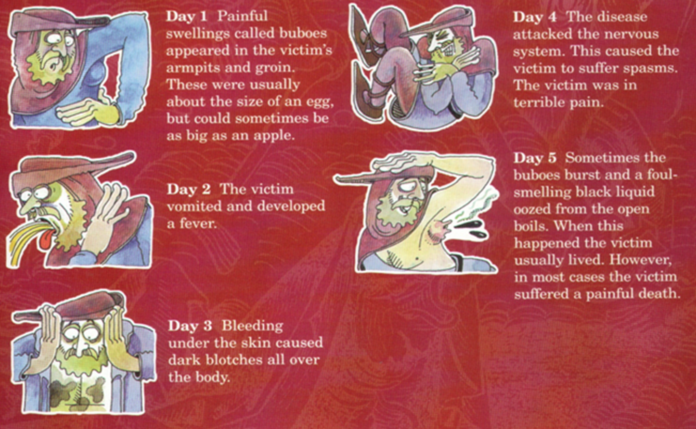

Early modern people did not know about germs or bacteria, and they struggled to find out what caused the plague. Some people believed the Great Plague was caused by punishment from God, being poisoned by bad air (miasma) or the alignment of stars and planets.
Task 1 – Video clip
Watch the following video clip and answer the four questions in the boxes below.
(Simple History - https://www.youtube.com/watch?v=LBvOZO1gmOE)
What actually caused the plague?

What did people believe caused the plague?

How did the rich deal with the plague?

How were the poor treated with the plague?

Task 2 – Impact of the Great Plague
Think about all of the things that happened to the people of London during the Great Plague. Write a paragraph explaining the positives and negatives of the Great Plague.
_____________________________________________________________________________________________________________________________________________________________________________________________________________________________________________________________________________________________________________________________________________________________________________________________________________________________________________________________________________________________________________________________________________________________________________________________________________________________________________
Lesson 10 – Can all dangerous situations be prevented?
Task 1 – The Great Fire of London
Below are a number of different sources. Please read through the sources and then use that information to complete the table that follows the sources. In this table you will have to write down the causes of the fire, what happened during the fire and the consequences of the fire.
London was a very busy place with lots of crowded wooden houses. Most building as they went up a storey (floor) jutted out over the street by a few feet. This meant that on the upper floors of some houses, neighbours opposite each other could reach out and shake hands across the street from their windows. In addition to this the streets were narrow.
At first, the Mayor of London refused to accept how serious the fire was. He was annoyed at being called from his bed to deal with the crisis and didn’t want to pull down houses (he was worried about who would have to pay for the damage) and he claimed it could be easily sorted out. He is quoted as saying, “a woman might piss it out”!
There were attempts to fight the fire by pouring on water, but this made little difference. The most effective way to stop a fire was to demolish the buildings in its path to create a firebreak, leaving nothing to burn. This required organised leadership but the Mayor of London, Thomas Bloodworth failed to do this.
After 5 days the wind dropped and the fire started to die out. 6 people are recorded as having died in the fire. £10 million of losses in buildings, goods and possessions.
The following had all been destroyed;-
13,200 houses, 87 churches, The Mayor’s office, the Royal Exchange
Even when buildings were pulled down it didn’t stop the fire. Wood, plaster and furniture lay in ruins in the streets and the strong winds blew setting these items and houses nearby on fire.
Fire and flame were the main ways that Londoners cooked their food and heated their homes.
Insurance companies were set up, if you paid a sum of money they would send a fire brigade out to put out the fire if needed.
As the Mayor of London was unable to deal with the fire, the King’s brother, the Duke of York was put in charge. He ordered whole rows of houses to be pulled down. The heat of the flames were so strong, it is said the stones of St. Paul’s Church exploded and the lead roof melted like snow.
In August of 1666 London had experienced hot and dry weather. Water supplies were much lower than normal.
On Sunday 2nd September 1666 a strong dry wind was blowing from the east.
New building regulations were introduced. Some of these new regulations were:-
*buildings now had to be made of brick or stone. Wood would be used only for windows and door frames
*high streets had to be 70-feet wide, but the narrowest alleyway had to be at least 16-feet wide
* only on 'high streets' were houses allowed to have balconies. On all other streets, bay windows, balconies, jetties and other projections were banned
Warehouses and workshops contained highly flammable materials such as tar, oils, wood, alcohol, gunpowder and chemicals. These warehouses were often next to ordinary people’s homes.
King Charles II wanted to rebuild London as quickly as possible. He asked architect, Christopher Wren to produce new plans for the street designs. Wren went onto to redesign and build St. Paul’s Cathedral with its very famous ‘dome’ roof.
In the early hours of Sunday 2nd September a spark at the bake-house of Thomas Farriner is alleged to have started the fire. Farriner said he had put out all of the fires in his oven properly. He claims to have been woken up just before 2am by his servant.

Causes of the fire (before) | Events (during) | Consequences of the fire (after)
Assessed Task 3
Please see Source A below and the question related to it.
To answer this question, you must support any own knowledge that you have about Oliver Cromwell and the English Civil War and use it to support your knowledge of the source.
Source A
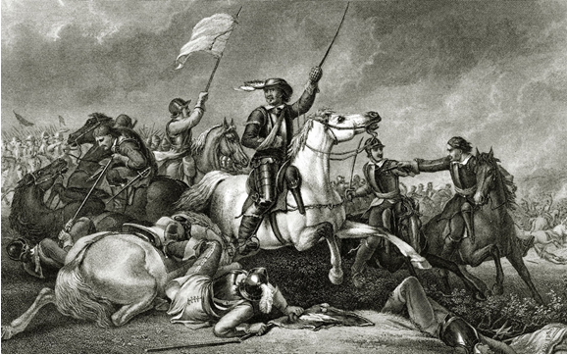

A drawing of Oliver Cromwell leading Parliamentarian soldiers into battle at Marston Moor. Parliament won this battle inflicting heavy casualties on the King’s army.

Source A supports the Parliamentarians during the English Civil War? How do you know?
Explain your answer using Source A and your own knowledge.
One way that Source A supports the Parliamentarians during the civil war is ____________
___________________________________________________________________________________________________________________________________________________________________________________________________________________________________________________________________________________.
Another way that Source A supports the Parliamentarians is shown by _________________
___________________________________________________________________________________________________________________________________________________________________________________________________________________________________________________________________________________.

