Study Guide – Vietnam Part 1

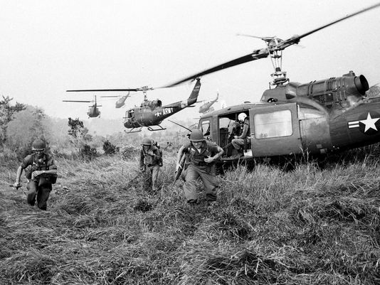

Name……………………..

GCSE History Unit 1 Section B Conflict and Tension in Asia, 1950-1975

What were the major events occurring within Vietnam by 1954?
BACKGROUND INTRO;

In 1860, France began its domination of the area and had, by the late 19th century, implemented its colonisation in a number of regions around the Gulf of Tonkin. During WW2, the Japanese government took control of much of the area and set up a puppet regime that was eventually forced out by the Vietnamese at the end of that war in 1945.
After WW2 and until 1955, France fought hard to regain their former territories in the region, but with a poorly organised army and little determination among the troops, their efforts soon collapsed. The French were finally defeated at Dien Bien Phu on the 8th of May 1954 by the communist general Vo Nguyen Giap. The French troops withdrew, leaving a buffer zone separating the North and South and set up elections in order to form a government in the South. The communist regime set up its headquarters in Hanoi under the leadership of Ho Chi Minh. Many North Vietnamese left the country and fled south where the self-proclaimed president, Ngo Dinh Diem had formed the Republic of Vietnam.
Between 1955 and 1960, the North Vietnamese with the assistance of the southern communist Vietcong, tried to take over the government in South Vietnam, and in November 1963 President Diem was overthrown and executed. The following year, the North Vietnamese began a massive drive to conquer the whole country aided by China and Russia.
Fearing a communist takeover of the entire region, the United States grew more and more wary of the progress of Ho Chi Minh and the Vietcong. The Americans were fixed on stopping communism from spreading any further.

With the Cold War at its height, the US leaders were worried that an attack on North Vietnam by the US would create tensions with the Chinese and Russians that would, in turn, lead to a larger conflict and possibly WW3. This created a difficult situation for the US and would eventually lead to many internal conflicts, which ultimately prevented the US from forming a firm policy for the region.

By 1950 the US began sending their first troops, firstly in an advisory role, which slowly escalated into a full-blown commitment.

Task 1 - Complete the storyboard

The French controlled Vietnam before WW2. | During WW2 the Japanese’s took over. | The French took Vietnam back over after WW2.
The French were defeated at the battle of Diem Bien Phu. | Between 1955 and 1960, the North Vietnamese with the assistance of the southern communist Vietcong, tried to take over the government in South Vietnam. | US began sending their first troops, firstly in an advisory role, which slowly escalated into a full-blown commitment.

Reasons for increasing involvement of the USA between 1963 and March 1965

Cold War/fear of Communism

*NB; China and North Korea had fallen to Communism, 1950, 1953. Iron Curtain established in Europe.

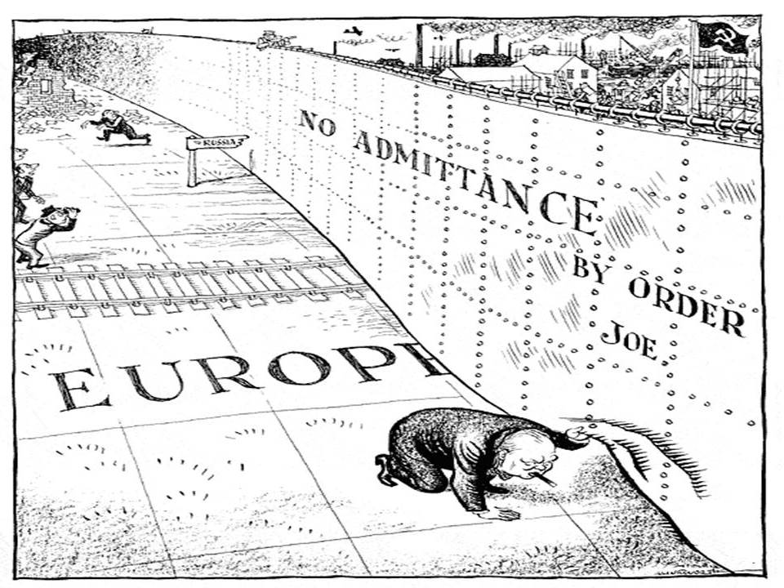
- Communists in North Vietnam got backing from USSR and China, therefore US Presidents more likely to view Vietnam in a Cold War context.
- Each President was reluctant to withdraw and admit Containment had failed.
- ‘Domino Theory’ – feared Chinese expansion into Indo-China – and threat to South East Asian countries.
- Repeat of Korea?

The French

Allowed Japanese invasion during WW2. At war with Ho Chi Minh and North 1945-54, the Northern freedom fighters used guerrilla warfare.

French finally defeated at Battle of Dien Bien Phu and the Geneva Conference was held – Vietnam was divided. Diem was established as President of Republic of Vietnam – supported by the US even though he refused to hold free elections as promised. Opposition grew in North – National Front for the Liberation of South Vietnam (NLF), the military wing was called the Vietminh or Vietcong.

Rise in numbers of VC/support for the Communists

Support for VC increased due to unpopularity of Diem – Persecution of Buddhists etc. VC attacked US air bases/military bases etc. Christmas 1964 bomb detonated and US camp near Pleiku attacked. VC 1961; 20, 000 VC 1964; 100, 000.

Gulf of Tonkin

Aug. 1964 – US claimed that there were 2 attacks on USS Maddox and Turner Joy. LBJ/McNamara asked for congressional support for avenging the attack, led to Gulf of Tonkin Resolution. Was it an excuse??

Others

Incompetence of Saigon government. President Diem was very corrupt.

Task 2 - Reasons for increasing involvement of the USA

Rank the above reasons in order of importance from most to least as to why USA became more involved in Vietnam between 1963 and March 1965. Then explain your ranking.

How effective were guerrilla tactics?

Aim. Avoid a battle with a stronger enemy by attacking with small groups, then ‘disappearing’. It depended on the support of local people & was intended to wear the Americans down
Who were the Vietcong? Recruited from men & women in South Vietnam, as well as some from the north. They followed a Code of Conduct which treated local people well & this helped them to get their support. They would kidnap & kill unpopular officials like tax collectors.
What were their tactics? Avoiding direct face-to-face fighting. Ambush patrols & kill or capture the soldiers. Set booby traps & plant bombs – ‘hit & run’ tactics.
How did they stay safe? They built networks of tunnels below ground – they had everything you would need to live eg kitchens & hospitals. They were strongly protected with booby traps & trip wires.
How were they supplied? From North Vietnam & neighbouring countries – the ‘Ho Chi Minh Trail’. It was 600 miles long. The route never closed, despite bombing & bad weather.

How did the US respond to guerrilla tactics?

Hearts & minds. Money to South Vietnam to improve conditions, eg building roads & schools. This was to show that the US was on their side & it worked in the towns which stayed loyal. But more effort was put into fighting than trying to win them over
Bombing. In 1964 the US used an attack on some boats as an excuse to begin bombing North Vietnam. US technology was much better than the Vietnamese
Operation Rolling Thunder. ‘Blanket bombing’ of North Vietnam, where they just attack everywhere. B-52 bomber were used to cause a lot of destruction but they did not surrender.
Search & destroy. Helicopters took troops to make surprise attacked on villages which meant the Vietcong could not get away or organsie resistance. Every home in a village was searched & if they found evidence of Vietcong there the whole village would be destroyed. Vietcong suspects were questioned & often killed – there was a lot of violence by the US because they wanted revenge. This led to the Vietcong developing a ‘find & kill’ method
Agent Orange & napalm. From 1966 Agent Orange was used: it destroyed leaves & undergrowth so there was nowhere for the Vietcong to hide. It was dangerous to humans, causing cancer. Napalm led to severe burning of skin. Chemical warfare did not make much difference to the war but it did lead to birth defects & many people turning against the war.
My Lai Massacre. 16th March 1968 3 platoons of soldiers went to My Lai. Lt Calley ordered that the village be destroyed. No villagers fought back. In 2 hours, about 500 unarmed men, women & children were killed. This is important because the American public learnt of the killings in 1969 & were shocked. Many people thought this made America as bad as the enemy. Lots of people started to turn against the war. Calley was the only person found guilty.

Task 3 – Tactics

Viet Cong or US Forces – Which side had the advantage?

Qualities of a successful army | Did this apply to the Viet Cong? | Did this apply to the US forces or allies? | Who had the advantage – Viet Cong or US forces?
Well-trained Soldiers
The right technology
Reliable supplies and equipment
Effective tactics
Support from the local population
Motivated and committed soldiers
Effective leadership
Other
The impact of the 1968 Tet Offensive on the war

Events of Tet

30th Jan 1968. VC/NVA launched Tet offensive. Main focal point = Saigon. 35 battalions under General Tran Van Tra struck as targets of political and military importance to Saigon government, i.e. Presidential palace, US embassy, radio stations, ARVN HQ etc. Across Saigon the VC used element of surprise to make initial gains but failed in overall objective due to quick reactions of powerful US/ARVN forces, i.e. fierce fighting at Tan San Nhut airbase where 3 VC battalions were almost wiped out. VC massacred at the hands of US/ARVN firepower and the offensive mainly collapsed within a few days.

EXCEPT, Hue – home of the old imperial capital and divided into 2 sections during the fighting. 31st Jan 1968 8, 000 of the 4th and 6th NVA regiments invaded Hue and seized the northern corner. US armed forces caught unawares, and only sent 1 marine command. By 11th Feb fighting still ferocious. By 24th Feb ARVN had won but 3, 000-6, 000 civilians died and 5, 000 NVA/VC. Khe Sanh marine base attacked (40, 000 NVA/VC versus 6,000 marines). Hence Operation Niagara launched; huge scale air bombing campaign of NVA/VC forces – killing 12, 000 (400 US/ARVN dead).

Consequences of Tet

Media covered the attack extensively. Though the attack failed for the Communist forces, they had managed to penetrate the very heart of the Saigon government’s power base. 84, 000 NVA/VC troops were committed to the attack, 58, 000 died. Many of the survivors fled over the border into Cambodia/Laos. US boasts of imminent victory were seen to be hollow – the war was very much to be a long drawn-out process. The death count seemed too high, especially civilians. The tide of war was then actually turned to favour the communists – unless the US could very quickly capitalise upon their success and wipe out the remaining Northern forces.

Westmoreland launched massive offensive (agreed by JCS) and called for 206, 000 troops to achieve a final victory. LBJ was dismayed and taken by surprise at the amount of troops needed plus the extra cost (Great Society), LBJ looked to Sec of Defence Clark Clifford – who advised against the huge increase in the number of troops and for a quick withdrawal (honourably). LBJ shortly after stood down as party leader nominee.

Task 4 – The Tet Offensive

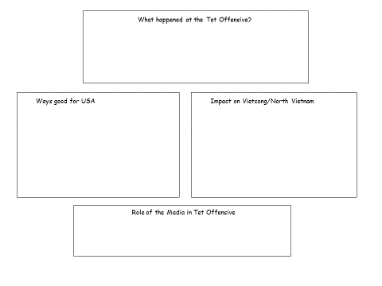
Additional Task – Write a Newspaper Headline and article explaining the success/ failures of the Tet Offensive. Think about if it would be mainly positive or negative.

